**Aim:** Performing calculations and creating parameters in Tableau.

**Theory:**

A parameter is a workbook variable such as a number, date, or string that can replace a constant value in a calculation, filter, or reference line.

Dataset use here is the **Super Store Data Set** to get the taxes of the sales done.

For example, you may create a calculated field that returns true if Sales is greater than $500,000 and otherwise returns False. You can replace the constant value of “500000” in the formula with a parameter. Then, using the parameter control, you can dynamically change the threshold in your calculation.

You can even create a dynamic parameter that’s set to automatically refresh its current value (to the result of a single-value, view-independent calculation), list of values (based on a data source column), or range of values. This will happen each time the workbook is opened and Tableau connects to the data source referenced by the parameter, or whenever you select Refresh from the data source’s context menu..

 Steps:

1.

**Output:**

**Calculations**

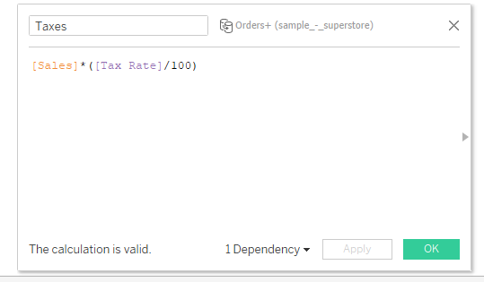

**Parameters**

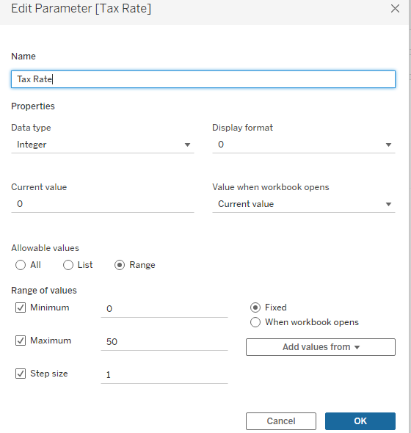

**Output:**

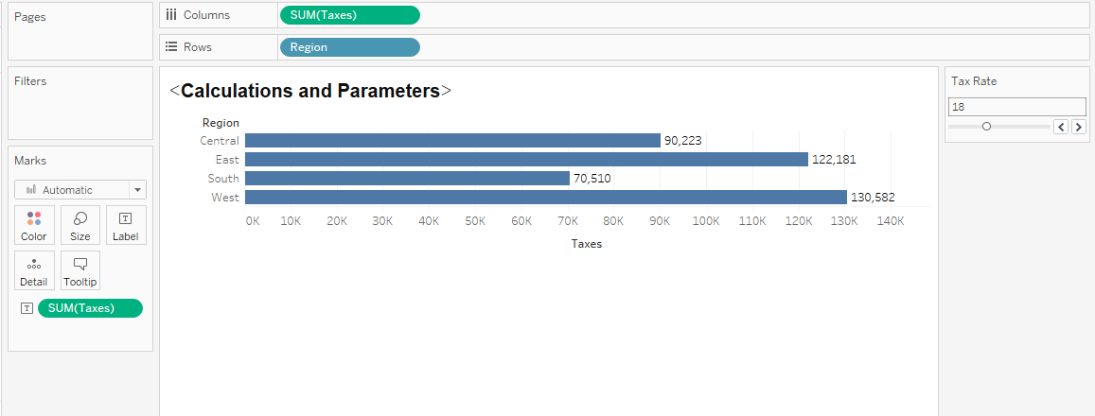

**Result:**

We have seen how to create calculation so that we can use it any time needed and also how to create parameter so that we can get the result easily by swapping the slider.